

Name: **VIRROSNY TS GANESH**

Login ID:virrosny@oasis-portal.com

Course title:[**ACCOUNTING FUNDAMENTALS**](http://study.oasis-portal.my/files/27/Accounting%20Fundamentals.pptx)

Subject Code: **BHM03**

Submitted date:14/08/2017

**Table of Contents**

|  |  |  |
| --- | --- | --- |
| No | Details | Page |
| 1 | Executive Summary | 3 |
| 2 | Introduction | 4-5 |
| 3 | Assignment Question |  |
|  | Part 1 | 6-9 |
|  | Part 2 | 10-13 |
|  | Part 3 | 14-15 |
|  | Part 4 | 16-19 |
| 4 | Conclusion | 20 |
| 5 | References | 21 |
| 6 | Appendix | 22 |

**Executive Summary**

In the module, I covered the topic about Accounting fundamentals. In starting part, we can see the introduction of accounting . What is the accounting fundamentals.In first part, I describe define a accounting concept meaning with more details ,double entry and role of accounting. In the second part, i explain the difference between accounts payable and accounts receivable. Third part, i will explain why does a company profit appear as a credit on its balance sheet. Finally, I will explain topic what is meant by reconciling an account.

INTRODUCTION ACCOUNTING

This explanation of accounting basics will introduce you to some basic accounting principles, accounting concepts, and accounting terminology. Once you become familiar with some of these terms and concepts, you will feel comfortable navigating through the explanations, quizzes, puzzles, and other features of AccountingCoach.com.

Some of the basic accounting terms that you will learn include revenues, expenses, assets, liabilities, income statement, balance sheet, and statement of cash flows. You will become familiar with accounting debits and credits as we show you how to record transactions. You will also see why two basic accounting principles, the revenue recognition principle and the matching principle, assure that a company's income statement reports a company's profitability.

In this explanation of accounting basics, and throughout all of the free materials and the PRO materials—we will often omit some accounting details and complexities in order to present clear and concise explanations. This means that you should always seek professional advice for your specific circumstances.

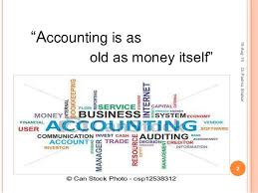

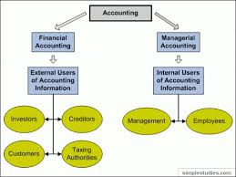

**Assignment Questions**

**Question 1**

In a brief but comprehensive response,define the role of accounting.

## The Role of Accounting

Accounting is often called “the language of business.” Why? Because it communicates so much of the information that owners, managers, and investors need to evaluate a company’s financial performance. These people are all stakeholders in the business—they’re interested in its activities because they’re affected by them. In fact, the purpose of accounting is to help stakeholders make better business decisions by providing them with financial information. Obviously, you wouldn’t try to run an organization or make investment decisions without accurate and timely financial information, and it’s the accountant who prepares this information. More importantly, accountants make sure that stakeholders understand the meaning of financial information, and they work with both individuals and organizations to help them use financial information to deal with business problems. Actually, collecting all the numbers is the easy part—today, all you have to do is start up your accounting software. The hard part is analyzing, interpreting, and communicating the information. Of course, you also have to present everything clearly while effectively interacting with people from every business discipline. In any case, we’re now ready to define accounting as the process of measuring and summarizing business activities, interpreting financial information, and communicating the results to management and other decision makers.

## Fields of Accounting

Accountants typically work in one of two major fields. Management accountants provide information and analysis to decision makers inside the organization in order to help them run it. Financial accountants furnish information to individuals and groups both inside and outside the organization in order to help them assess its financial performance.

In other words, management accounting helps you keep your business running while financial accounting tells you how well you’re running it.

## Management Accounting

Management accounting plays a key role in helping managers carry out their responsibilities. Because the information that it provides is intended for use by people who perform a wide variety of jobs, the format for reporting information is flexible. Reports are tailored to the needs of individual managers, and the purpose of such reports is to supply relevant, accurate, timely information in a format that will aid managers in making decisions. In preparing, analyzing, and communicating such information, accountants work with individuals from all the functional areas of the organization—human resources, operations, marketing, and finance.

## Financial Accounting

Financial accounting is responsible for preparing the organization’s financial statements—including the income statement, the statement of owner’s equity, the balance sheet, and the statement of cash flows—that summarize a company’s past performance and evaluate its current financial condition. In preparing financial statements, financial accountants adhere to a uniform set of rules called generally accepted accounting principles (GAAP)—the basic principles for financial reporting issued by an independent agency called the Financial Accounting Standards Board (FASB). Users want to be sure that financial statements have been prepared according to GAAP because they want to be sure that the information reported in them is accurate. They also know that they can compare the statements issued by one company to those of another company in the same industry.

While companies headquartered in the United States follow U.S.-based GAAP, many companies located outside the United States follow a different set of accounting principles called International Financial Reporting Standards (IFRS). These multinational standards, which are issued by the International Accounting Standards Board (IASB), differ from U.S. GAAP in a number of important ways. IFRS, for example, is a little stricter about the ways you can calculate the costs of inventory, but we’re not going to dwell unnecessarily on such fine distinctions. Bear in mind, however, that, according to most experts, a single set of worldwide standards will eventually emerge to govern the accounting practices of both U.S. and non-U.S. companies.

## Who Uses Financial Accounting Information?

The users of managerial accounting information are pretty easy to identify—basically, they’re a firm’s managers. We need to look a little more closely, however, at the users of financial accounting information, and we also need to know a little more about what they do with the information that accountants provide them.

## Owners and Managers

In summarizing the outcomes of a company’s financial activities over a specified period of time, financial statements are, in effect, report cards for owners and managers. They show, for example, whether the company did or didn’t make a profit and furnish other information about the firm’s financial condition. They also provide information that managers and owners can use in order to take corrective action.

## Investors and Creditors

If you loaned money to a friend to start a business, wouldn’t you want to know how the business was doing? Investors and creditors furnish the money that a company needs to operate, and not surprisingly, they feel the same way. Because they know that it’s impossible to make smart investment and loan decisions without accurate reports on an organization’s financial health, they study financial statements to assess a company’s performance and to make decisions about continued investment.

## Government Agencies

Businesses are required to furnish financial information to a number of government agencies. Publicly owned companies, for example—the ones whose shares are traded on a stock exchange—must provide annual financial reports to the Securities and Exchange Commission (SEC), a federal agency that regulates stock trades. Companies must also provide financial information to local, state, and federal taxing agencies, including the Internal Revenue Service.

## Other Users

A number of other external users have an interest in a company’s financial statements. Suppliers, for example, need to know if the company to which they sell their goods is having trouble paying its bills or may even be at risk of going under. Employees and labor unions are interested because salaries and other forms of compensation are dependent on an employer’s performance.

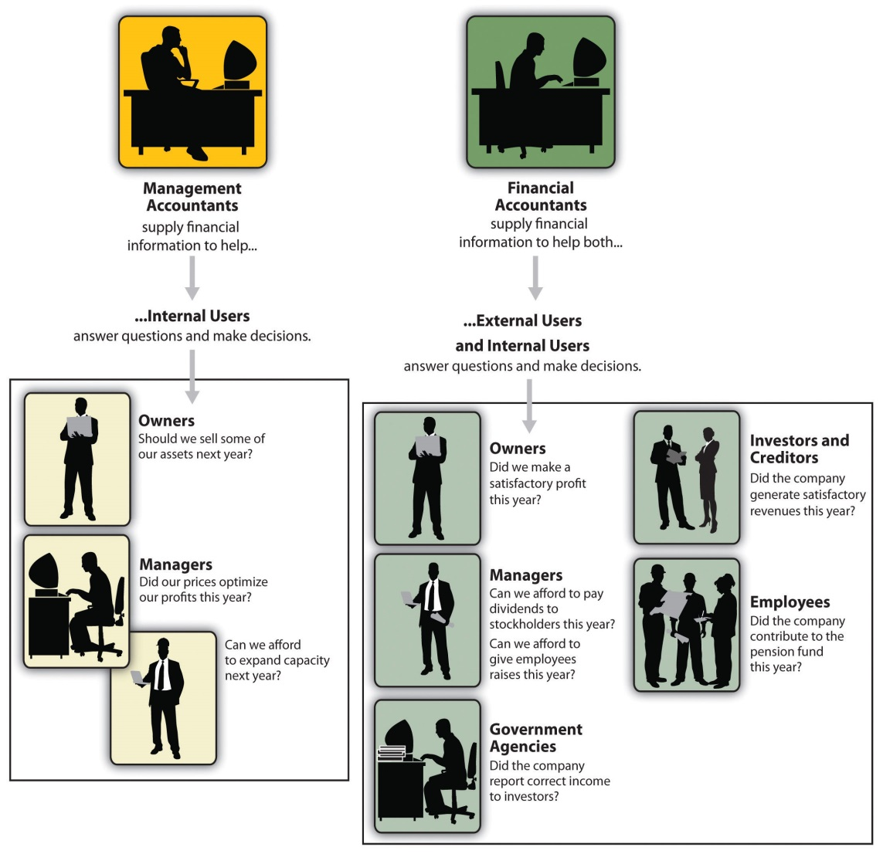

**Question 2**

What is the differences between accounts payable and accounts receivable?

|  |  |  |
| --- | --- | --- |
|  | Account receivable | Account payable |
| Definition | Payment which the company will receive from its customers who have purchased goods and services on credit. Customers who have purchased goods and services are called debtors. | When a company purchases goods on credit which needs to be paid back in a short period of time. Account payable is short-term debt payment which needs to be paid to avoid default. |
| Family | Assets | Liabilities |
| Example | Sold goods RM 700 on credit | Bought goods RM500 on credit |

1. Purchase

|  |  |
| --- | --- |
| Dt | Cr |
| Cash RM 1200 |  |

Cash

|  |  |
| --- | --- |
| Dt | Cr |
|  | Purchase RM 1200 |

1. Salaries expenses

|  |  |
| --- | --- |
| Dt | Cr |
| Cash RM 900 |  |

Cash

|  |  |
| --- | --- |
| Dt | Cr |
|  | Salaries expenses RM 900 |

1. Rental expenses

|  |  |
| --- | --- |
| Dt | Cr |
| Bank RM 2000 |  |

Bank

|  |  |
| --- | --- |
| Dt | Cr |
|  | Rental expense RM 2000 |

1. Purchase

|  |  |
| --- | --- |
| Dt | Cr |
| Creditor RM 1500 |  |

Creditor

|  |  |
| --- | --- |
| Dt | Cr |
|  | Purchase RM 1500 |

1. Cash

|  |  |
| --- | --- |
| Dt | Cr |
| Sales RM 1500 |  |

Sales

|  |  |
| --- | --- |
| Dt | Cr |
|  | Cash RM 1500 |

1. Cash

|  |  |
| --- | --- |
| Dt | Cr |
| Commission received RM 1300 |  |

Commission received

|  |  |
| --- | --- |
| Dt | Cr |
|  | Cash RM 1300 |

1. Cash

|  |  |
| --- | --- |
| Dt | Cr |
| Discount received RM 250 |  |

Discount received

|  |  |
| --- | --- |
| Dt | Cr |
|  | Cash RM 250 |

1. Debtor

|  |  |
| --- | --- |
| Dt | Cr |
| Sales RM 250 |  |

Sales

|  |  |
| --- | --- |
| Dt | Cr |
|  | Debtor RM 250 |

**Question 3**

Why does company profit appear as a credit on its balance sheet

## Introduction to Balance Sheet

A Balance Sheet is fundamentally a statement of financial position as of a certain date. A balance sheet can be prepared for an individual, a partnership, a corporation or any other entity that has assets and debts.

Balance sheets are typically compiled to report to owners or other interested parties such as lenders, exactly what the company looks like financially at a given point in time. In order to have amounts to report, an entity would need a financial record keeping system that would show balances at the end of a day, week or whatever reporting timeframe was needed.

A basic balance sheet will have three sections; [assets](http://accounting.fundamentalfinance.com/common-assets.php), [liabilities](http://accounting.fundamentalfinance.com/common-liabilities.php), and owner's equity. A balance sheet is so named because it must be "balanced" using the formula; assets minus liabilities equals owner's equity.

The simplest business reporting will typically be done on the "cash basis." Cash basis means simply that a record is made of a transaction, e.g. a sale of goods, when cash changes hands. Let's assume that John Doe borrows $5,000 from the bank to start a small business selling his childhood collection of baseball cards. John needs the $5,000 to pay rent on a small storefront and pay for electricity in the store until things get going. John has valued his collection conservatively at $10,000. Before any sales are made or expenses paid, John's balance sheet would look like this:

|  |  |
| --- | --- |
| **Assets** |  |
| Cash | $ 5,000 |
| Card Collection | $10,000 |
| **Liabilities** |  |
| Bank Loan | $ 5,000 |
| **Owner's Equity** | $10,000 |

Every transaction in John's business will have an effect on his balance sheet. As sales are made, there is an increase in cash and a decrease in the value of the card collection. For example, if John sells a card that he valued at the start of the business at $1.00, for $2.00, he has made a profit of $1. Profit or loss is the result of business operations where all expenses and revenue are netted to show the final result. The profit John earned selling the card adds to his equity, balancing the statement.

Accounting has long realized that not all businesses have the luxury of operating on a strictly cash basis. As a result businesses have amounts that are due to them, as when sales are made on credit, and they owe money to other businesses when they buy on credit. These amounts are called receivables and payables and are also reported on a balance sheet so that on a given date, an accurate picture of the business will be reported.

As businesses are incorporated, many other complexities can show up in the balance sheet. Corporations sell ownership shares, typically in classes of stock. The stock will be shown in the equity section along with any restrictions or reservations that may be placed on them.

**Question 4**

What is meant by reconciling an account

Account [reconciliation](http://www.investopedia.com/video/play/reconciliation-0/) is also important for businesses. Businesses must reconcile their accounts to check for fraud and to prevent [balance sheet](http://www.investopedia.com/terms/b/balancesheet.asp) errors. Businesses typically use [accounting software](http://www.investopedia.com/terms/a/accounting-software.asp) to help them perform account reconciliations. Mistakes can have serious ramifications for publicly traded companies. For example, an [auditor](http://www.investopedia.com/terms/a/auditor.asp) who reviews the company’s [financial statements](http://www.investopedia.com/terms/f/financial-statements.asp) in accordance with federal regulations such as the Sarbanes-Oxley Act could find a material error, which the company would have to publicly disclose as a failure of controls, a material misstatement and/or a material weakness. Without accurate financial information, a company cannot make well-informed decisions.

## Difference Between Double-Entry Reconciliation and Account Conversion

In double-entry accounting, an accountant posts every financial transaction in two columns of a business's balance sheet. For example, if the business takes out a long-term loan for $10,000, the accountant credits long-term debt or notes payable with that amount and debits the cash column with the same amount. When these amounts are added together, the account reconciles or balances at 0.

Similarly, imagine that a business incurs an invoice for carpet cleaning services. It credits the amount of the invoice in its accounts payable column, and it debits its column devoted to office cleaning and similar expenses for the same amount. When the company pays the bill, it debits accounts payable and credits the office cleaning column.

Under the account conversion method, businesses or individuals compare records such as receipts or canceled checks with the entries in its ledger.

In bookkeeping, a bank reconciliation is a process that explains the difference on a specified date between the bank balance shown in an organization's [bank statement](https://en.wikipedia.org/wiki/Bank_statement), as supplied by the bank, and the corresponding amount shown in the organization's own accounting records.[[1]](https://en.wikipedia.org/wiki/Bank_reconciliation#cite_note-Warren2010-1)

Such differences may occur, for example, because

* [cheques](https://en.wikipedia.org/wiki/Cheque) issued by the organization have not been presented to the bank
* a banking transaction, such as a credit received, or a charge made by the bank, has not yet been recorded in the organization's books
* either the bank or the organization itself has made an error.

Sometimes it may be easy to reconcile the difference by looking at very recent [transactions](https://en.wikipedia.org/wiki/Financial_transaction) in the bank statement and the organization's own accounting records (cash book) and seeing if some combination of them tallies with the difference to be explained. Otherwise it may be necessary to go through and match every transaction in both sets of records since the last reconciliation, and see what transactions remain unmatched. The necessary adjustments should then be made in the cash book, or reported to the bank if necessary, or any timing differences recorded to assist with future reconciliations.

For this reason, and to minimise the amount of work involved, it is good practice to carry out such reconciliations at reasonably frequent intervals. Reconciliations may be assisted by specialised [accounting software](https://en.wikipedia.org/wiki/Accounting_software).

A Bank reconciliation statement is a statement prepared as part of the reconciliation which sets out the entries which have caused the difference between the two balances.

## Bank Reconciliation Defined

Have you ever balanced your checkbook? Why did you do that? Was it to make sure that you didn't make any mistakes when you were adding deposits or subtracting expenses? I bet it was because you wanted to make sure that your balance in your checkbook was the same as the balance in the bank, right? Everything that we just talked about refers to what we in accounting commonly call doing a bank reconciliation. A bank reconciliation is the balancing of a company's cash account balance to its bank account balance.

## Preparing a Reconciliation

Since it is really important to make sure that the cash account and the bank account balances match, a company prepares bank reconciliations on a monthly basis. There are several steps that are involved in this, but, even so, it is a relatively simple thing to do. Let's go through the steps and prepare the reconciliation.

Step 1: Collect the documents that you will need to prepare the reconciliation. The most common documents would be the bank statement that is received from the bank and the check register for the month. In the accounting industry, most check registers are printed off of accounting software and used for the reconciliation. The bank statement tells you what the bank balance was at the beginning of the month, the deposits the bank has on record for the account, the withdrawals that have been made from the account, and the ending balance of the account on a specific date. The check register will show all the deposits and withdrawals that were made by the company during a given time period. There is one key difference between the bank statement and the check register. The bank statement only lists deposits and withdrawals that have processed through the bank, while the check register lists all the deposits and withdrawals that a company had in a specific period, regardless of if it has cleared the bank or not.

Step 2: The second step in preparing the bank reconciliation is the most tedious. The object of this step is to account for all the deposits and withdrawals that a company has recorded and that have also cleared the bank. If you are manually preparing the reconciliation, you would highlight or check off the entries that are common among the two. In a computerized accounting program, you can simply just click on the entries to mark them as cleared. Cleared means that the item has been recorded in both the company's records and the bank's records.

Step 3: Once you have marked the items that are cleared on the check register, you move to the next step. In this step, you will make a list of any items that have been recorded in the check register but have not cleared the bank. Typically, a company will always have outstanding debits in the month. Outstanding debits are checks and other withdrawals that have been recorded in the company's cash account but have not yet been recorded in the bank's accounting records. There may also be outstanding credits that need to be accounted for. Outstanding credits are deposits that have been recorded in company's records but don't yet appear on the bank's records.

Step 4: Now that you have all the outstanding debits and outstanding credits together, it's time to do the math. Any debits that haven't been accounted for will need to be deducted from the balance on the bank statement. Likewise, any credits that have not been accounted for will be added to the balance on the bank statement. In a perfect world, once this step is complete, the current balance in the checkbook should match the adjusted bank statement balance.

Step 5: Notice that I just said, 'in a perfect world the balances would match'. It's not always a perfect world. Sometimes the balances don't match. That's when your detective skills come into play. If the current balance in the checkbook does not match the adjusted bank statement balance, then you have to start looking for errors. The most common error that occurs and is discovered in the reconciliation process is called transposition. Transposition occurs when the order of numbers are inadvertently switched during the recording process. For example, let's say that a check was written for $412 to pay a utility bill but was recorded in the checkbook as $421.00. That error would cause a $9 difference between the two balances. Of course, there could be other errors that cause the balances not to equal. Either a check or a deposit may not have been recorded or something may have been recorded twice. These are things that can be found and fixed in the reconciliation process.

**Conclusion**

Accounting is termed as a process meant for keeping records of the transactions financial in nature. Accounting is a practical, engaging subject with concepts that requires skills in both legal studies as well as mathematics. Accounting enables businesses to analyse the financial performance by determining the profit or loss made during a certain period. Hence it is sometimes called the “language of business”. Accounting involves the process of identifying, measuring, recording and communicating the economic events of an organization (business or non-business) to interested users of the information.

**References**

**1.http://www.businessdictionary.com/definition/accounting-concepts.html**

**2.** [**https://www.accountingcoach.com/blog/profit-credit-on-balance-sheet**](https://www.accountingcoach.com/blog/profit-credit-on-balance-sheet)

**3.** [**http://accounting-simplified.com/financial/what-is-accounting.html**](http://accounting-simplified.com/financial/what-is-accounting.html)

**4.** [**http://www.careerride.com/fa-systems-of-accounting.aspx**](http://www.careerride.com/fa-systems-of-accounting.aspx)

**5.** [**https://www.acowtancy.com/textbook/acca-f3/e4-bank-reconciliations/differences-between-cash-book-and-bank-statement/notes**](https://www.acowtancy.com/textbook/acca-f3/e4-bank-reconciliations/differences-between-cash-book-and-bank-statement/notes)

**Appendix**

